EE491 / EE492 PROJECT REPORT
DATE: XX/XX/XXXX
ADVISOR NAME SURNAME
STUDENT NAME, SURNAME AND NUMBER
DEPARTMENT OF ELECTRICAL AND ELECTRONICS ENGINEERING
PROJECT TITLE
ABSTRACT

TABLE OF CONTENTS

ABBREVIATIONS 3
LIST OF FIGURES 4
LIST OF TABLES 5
1. INTRODUCTION 6
1.1. Sample Subsection 6
2. PROBLEM DEFINITON 7
2.1. Sample Subsection for Chapter-2 7
2.2. Sample Subsection for Chapter-2 7
3. PROPOSED SOLUTION 8
3.1. Sample Subsection for Chapter-3 8
4. RESULTS AND DISCUSSIONS 9
5. CONCLUSIONS 10
REFERENCES 11
APPENDIX 12

ABBREVIATIONS

IEEE : Institute of Electrical and Electronics Engineers
MoM : Method of Moments

LIST OF FIGURES

Figure 1 Block Diagram 7
Figure 2 Radiation Pattern 7
Figure 3 Width of the waveguide vs. frequency variation 9

LIST OF TABLES

Table 1 Dimensions vs Cutoff frequency variation 9

- INTRODUCTION

This section should be devoted to describe related scientific studies (scientific papers, reports, books etc.) which has been published in the literature.

  - Sample Subsection

The general description of the project and connections of the literature should be mentioned in this section.

- PROBLEM DEFINITON
The detailed project statement has to be explained in this section.

Equations should be written with an editor e.g. Mathtyp. Formulations cannot be inserted as picture format.

Formulas should be written centered with the equation number, e.g.

$∇×\vec{E }=-\frac{∂\vec{B}}{∂t}$ (1)

Figures and Tables should be also centered and have separate captions, and numbers which are listed in List of Figures and List of Tables, respectively.

Information
Transmitter
Receiver
Channel

Figure 1 Block Diagram

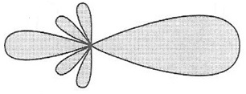
Figure 2 Radiation Pattern

  - Sample Subsection for Chapter-2
……………
……………
  - Sample Subsection for Chapter-2
……………

- PROPOSED SOLUTION
The method which will be used in the project studies should be clarified in this section.
  - Sample Subsection for Chapter-3
………….

- RESULTS AND DISCUSSIONS
Results obtained during the project study should be presented in this section. Discussions on the scientific findings should be reported in a clear form.

Waveguide Type | width (cm) | height(cm) | Cuttoff frequency of TE₁₁ (GHz)
WG-1 | 1 | 1 | 21.213
WG-2 | 2 | 1 | 16.770
WG-3 | 3 | 1 | 15.811
WG-4 | 4 | 1 | 15.461

Table 1 Dimensions vs Cutoff frequency variation

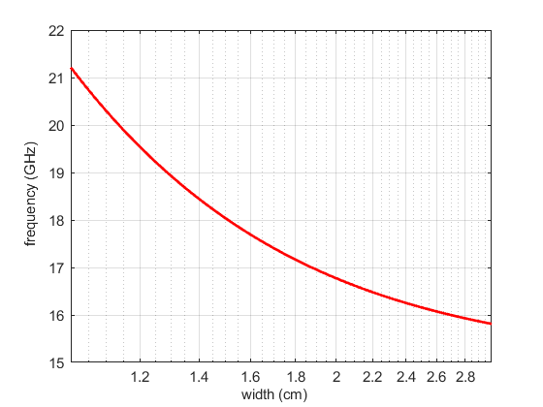
Figure 3 Width of the waveguide vs. frequency variation

- CONCLUSIONS
General description of the project, the most interesting contributions and observations, and possible extensions should be emphasized in here.

REFERENCES

[1] Einstein, A., Podolsky, B., & Rosen, N. (1935). Can quantum-mechanical description of physical reality be considered complete?. Physical review, 47(10), 777.
[2] Cover, T. M., & Thomas, J. A. (2012). Elements of information theory. John Wiley & Sons.
[3] Grossglauser, M., & Tse, D. (2001). Mobility increases the capacity of ad-hoc wireless networks. In INFOCOM 2001. Twentieth Annual Joint Conference of the IEEE Computer and Communications Societies. Proceedings. (Vol. 3, pp. 1360-1369).

APPENDIX

